PAPER REF: (to be assigned by the editors)

A MECHANICAL ANALYSIS OF POLYPROPYLENE PROSTHESES USED IN PELVIC FLOOR REPAIR

Pedro Martins1(*), José Afonso2, Renato Jorge3, M. Girao2, António Fernandes3

1Institute of Mechanical Engineering (IDMEC), University of Porto, Porto, Portugal

2Department of Gynecology, Federal University of São Paulo, São Paulo, Brazil

3Department of Mechanical Engineering and Industrial Management (DEMEGI), University of Porto, Portugal

(*)*Email:* [palsm@fe.up.pt](mailto:palsm@fe.up.pt1)

**ABSTRACT**

This work compares the tensile (uniaxial tension test) stiffness of different meshes used as prostheses in pelvic floor repair surgeries. Five different commercial meshes were analysed, all made from polypropylene but with different geometries: Aris™, TVTO™, Uretex™, Avaulta™ and Auto Suture ™. The mechanical tests performed allowed to identify significant differences on the mechanical properties of the polypropylene meshes used in urogynecology surgeries.

***Keywords:*** biomechanics, polypropylene, prosthesis, urogynecology.

**INTRODUCTION**

There is erosion phenomena associated with polypropylene prostheses used in pelvic floor repair surgeries. This phenomenon consists on the inflammation of the biologic structures directly in contact with the artificial material. Several problems can occur as a consequence from pain and discomfort to an extreme loss of tissue, leading ultimately to a new surgery for prosthesis removal or substitution. For the case of stress urinary incontinence (SUI), the erosion rate associated is approximately 1–3% (Petros, 2007). Some evidence points to the fact that mesh stiffness may be related with erosion (Siegel, 2005). The flexibility differences of the meshes (all monofilament polypropylene tapes with macropores) are due to the differences in mesh weave and surgical suture thickness.

A total of 15 individual tests were performed. The sample length was 40 mm (±0.5 mm) with slightly varying width according with their technical specifications (≈10 mm). The mechanical tests were performed at slow displacement rate (5 mm/s) and at room temperature (≈25º C). The mechanical testing was carried out on a testing setup purposely built for low load soft tissue testing (Martins, 2006). According with a previous study (Dietz, 2003), temperature doesn’t influence the results significantly. From the tensile test two stiffness parameters were extracted EI and EII. EI used load-displacement data in the range of 0-500 g, the estimated physiologic load range (Dietz, 2003). For the calculation of EII the load range was 500-2000 g.

## RESULTS AND CONCLUSIONS

The results from the tensile tests are shown in Fig. 1. The load-displacement curve has two different regions. The first region is nonlinear and evolves to an approximately linear region. Table 1 shows the results for the stiffness parameters EI and EII.

The most significant difference of tensile stiffness behaviour appears between Aris™ and TVTO™ on the EI (p=0.001) and EII (p=0.0003) regions.

Table 1 - Uniaxial tension test results

|  |  |  |  |  |
| --- | --- | --- | --- | --- |
| **Tapes** | **EI [(N/m)x1000]** | **StD** | **EII [(N/m)x1000]** | **StD** |
| **Aris™** | 2.3898 | 0.2154 | 5.3705 | 0.5432 |
| **TVTO™** | 0.9428 | 0.1919 | 1.3083 | 0.2075 |
| **Uretex™** | 1.1367 | 0.1918 | 3.2231 | 0.1853 |
| **Avaulta™** | 1.7986 | 0.1925 | 3.7810 | 0.7626 |
| **Auto Suture™** | 1.0507 | 0.0766 | 2.2624 | 0.2658 |

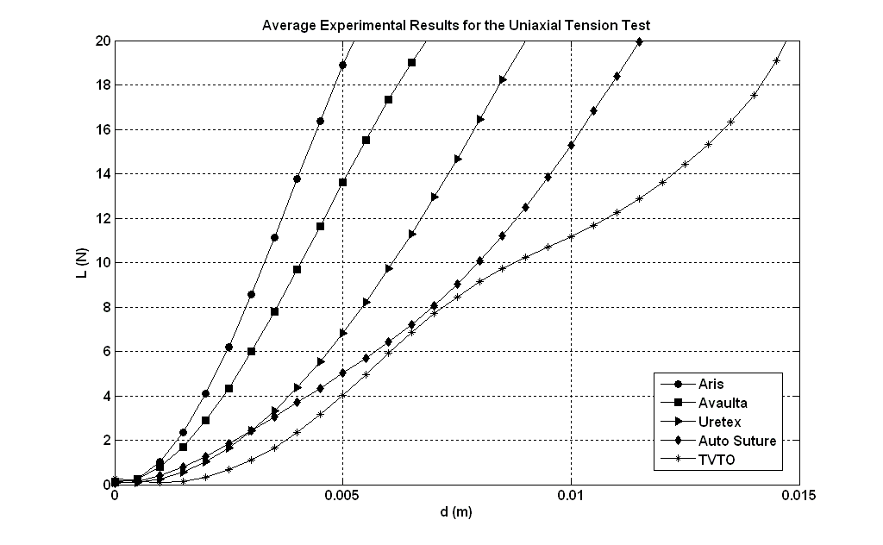

Fig. 1 - Tensile test results

This study shows that there are substantial differences on the mechanical properties of different urogynecology meshes. Further tests should be performed in order to analyze other mechanical properties, such as flexural properties.

**ACKNOWLEDGMENTS**

The authors gratefully acknowledge the funding by Ministério da Ciência, Tecnologia e Ensino Superior, FCT, Portugal, under grants PTDC/SAU-BEB/71459/2006 and SFRH/BD/41841/2007.

**REFERENCES**

Dietz H, Vancaillie P, Svehla M, Walsh W, Steensma A, Vancaillie T. Mechanical properties of urogynecologic implant materials. International Urogynecology J, 2003, 14, p. 239-243.

Martins PALS, Jorge RMN, Ferreira AJM. A comparative study of several material models for prediction of hyperelastic properties: Application to Silicone-Rubber and Soft Tissues. Strain, 2006, 42, p. 135-147.

Petros PE. Repairing damage fascia: ongoing and postoperative considerations. In: Petros PE (ed) The female pelvic floor. Springer, Berlin, 2007 p. 108-156.

Siegel AL. Vaginal mesh extrusion associated with use of Mentor transobturator sling. Urology, 2005, 66, p. 995-999.